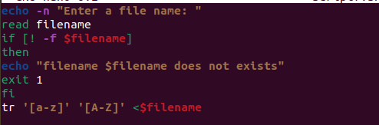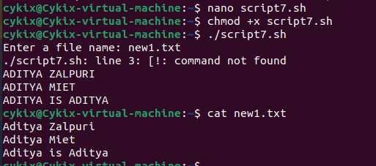

1. Write a shell script to convert file taken as argument to uppercase

b) Write a shell script to check a command line argument is file or directory .

